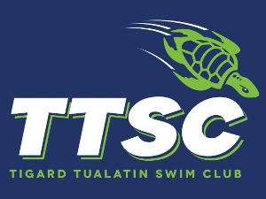

How to be an Involved and Supportive Parent, and why your involvement is vital to the club’s success:
- Help with and attend team activities (refreshments, parties, donations, and fundraising events)
- Serve as a “welcome wagon” to newcomers on the TEAM – newbies don’t know a swim club is a small business, not just another youth sports activity. Help prevent them from feeling overwhelmed!
- Coordinate the TEAM newsletter
- Organize/order TEAM apparel and/or equipment
- Help with facility maintenance
- Volunteer to chaperone
- Be a timer or official at meets
- Serve on the Board of Directors, or serve on a committee
- Represent your TEAM to the LSC
- Be the “Dumb Question” liaison

Are you a Pressure Parent?
- Is winning more important to you or your child?
- Is your disappointment obvious?
- Can only you “psych up” your child?
- Is winning the only way your child can enjoy sports?
- Do you conduct post-mortems after competition or practice?
- Do you feel you have to fore your child to practice?
- Can you do better coaching your own child?
- Do you dislike your child’s opponents?
- Are your child’s goals more important to you?
- Do you provide material rewards for performance?

10 Commandments for Swimming Parents
by Rose Snyder, adapted from Ed Clendaniel’s 10 Commandments for Little League Parents
- Thou shalt not impose thy ambitions on thy child.
- Thou shalt be supportive no matter what.
- Thou shalt not coach thy child.
- Thou shalt have only positive things to say at a competition.
- Thou shalt acknowledge thy child’s fears.
- Thou shalt not criticize the officials.
- Thou shalt respect thy child’s coach.
- Thou shalt be loyal to thy team.
- Thou shalt have other goals besides swimming.
- Thou shalt not expect thy child to become an Olympian.

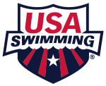
What is USA Swimming?

USA Swimming is the National Governing Body for competitive swimming in the United States. We are a 400,000-member service organization that promotes the culture of swimming by creating opportunities for swimmers and coaches of all backgrounds to participate and advance in the sport through teams, events and education.
Our membership is comprised of swimmers from the age group level to the Olympic Team, as well as coaches and volunteers. Members can get involved through our more than 2,800 teams across the nation.
USA Swimming is also responsible for selecting and training teams for international competition including the Olympic Games, and strives to serve the sport through its core objectives including:
• Build the base
• Promote the sport
• Achieve competitive success
USA Swimming was conceived in 1978 with the passage of the Amateur Sports Act, which specified that all Olympics sports would be administered independently. Prior to this act, USA Swimming was the Competitive Swimming Committee of the Amateur Athletic Union (AAU) located in Indianapolis, IN. USA Swimming Headquarters office was established in Colorado Springs, CO, in 1981 and is located at the Olympic Training Center.

As the National Governing Body for the sport, USA Swimming is responsible for the conduct and administration of swimming in the United States. In this capacity, USA Swimming formulates the rules implements the policies and procedures, conducts the national championships, disseminates safety and sports medicine information and selects athletes to represent the United States in international competition.

How is USA Swimming organized?

International – The international federation for the aquatic sports is the Federation Internationale de Natation Amateur (FINA). USA Swimming is affiliated with FINA through United States Aquatic Sports (USAS), made up of the four aquatic sports – swimming, synchronized swimming, , diving, and water polo.

National – USA Swimming is a group member of the United States Olympic Committee (USOC) and has voting representation in the USOC House of Delegates.

Zone – USA Swimming is divided into four separate zones – Central, Eastern, Southern, and Western. Each zone elects two representatives to the national Board of Directors.

Local – Within the United States, there are fifty-nine (59) Local Swimming Committees (LSCs). Each LSC is responsible for administering USA Swimming activities in a defined geographical area and has its own set of bylaws under which it operates. A House of Delegates with representation of athletes, coaches, members of the Board of Directors, and clubs is responsible for managing the business affairs of the LSC.

How USA Swimming Operates

USA Swimming is a non-profit organization made up of very dedicated volunteers. Interested individuals donate their time, energy and expertise at every level from the national Board of Directors to the local swimming clubs. There are 50 standing committees. Staff liaisons, alone with these committees, create, implement, and evaluate USA Swimming programs. The House of Delegates meets annually to determine the rules and regulations for the following year. Between yearly meetings of the House of Delegates, an elected USA Swimming Board of Directors is charged with the responsibility of making decisions for USA Swimming

USA Swimming Headquarters

USA Swimming Headquarters provides a variety of services and programs for its membership. Among the many services are publications, educational programs, fund-raising activities, sports medicine programs, resources, and general information and swimming related activities. USA Swimming staff is available to assist you in answering questions or providing additional information about USA Swimming.

Contact Us
1 Olympic Plaza
Colorado Springs, CO 80909
719-866-4578
General Inquiries: info@usaswimming.org
Membership Inquiries: membership@usaswimming.org

Office Hours
Monday - Friday (except holidays)
8:30 am - 5:00 pm Mountain Time

Create your Deck Pass account

Deck Pass is your to tool to create engagement, inspiration and insights to improve swimming performance. Previously, Deck Pass was known as the official app of USA Swimming. Today it is so much more! All of amazing existing functionality of Deck Pass still exists - patches, goals, best times, friends. Deck Pass will connect you with the USA Swimming that you want! Personalized articles, videos, new insights and data are all apart of the new Deck Pass!
In addition, Deck Pass is now available for more than just Swimmers, Coaches and Non Members. We've added customized accounts for Parents, Officials and Team Leaders. Get started today to get the most out both in and out of the pool!

IMX/IMR and VCC

IMX/IMR

IM Xtreme is a program that allows USA Swimming members to track their times (or coaches to track their team's times) against swimmers all across the nation! Just by swimming a specific program of events, you can see where you rank against your teammates, your region and yes, even across the USA!
NOT QUITE IMX READY? TRY THE IMREADY CHALLENGE!
IM Ready is the little brother of IM Xtreme, tailored toward our younger swimmers. Does 200 yards seem a little much? Then start getting "IM Ready" by swimming shorter distances, and keeping track of your improvements.

Important Note About IMR and IMX Scores
An IMR or IMX score is only established after a swimmer has swum all of the events required for their age group in a sanctioned meet since the start of the current season; both short and long course seasons start September 1 and end August 31 for IMR/IMX purposes.
Additionally, a swimmer must complete all of the events in the same course (SCY or LCM) to have a score in that particular course.

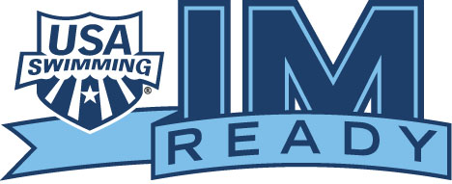
IM READY (IMR)
The first step in the IMX Challenge is IM Ready (or IMR). To get "IM Ready," swimmers compete in a

series of five events at shorter distances. Below, we've listed the line-up by age groups.

9 & Under; 10-year olds: 100 Free, 50 Back, 50 Breast, 50 Fly, 100 IM (SC) or 200 IM (LC)

11-year olds; 12-year olds: 200 Free, 50 Back, 50 Breast, 50 Fly, 100 IM (SC) or 200 IM (LC)

13, 14, 15, 16, 17, & 18-year olds: 200 Free, 100 Back, 100 Breast, 100 Fly, 200 IM

Once you've swum each event at least once at an official meet, you can log-in to your Deck Pass Account, and find out where you rank against all the other swimmers on your club team. You do not need to complete the IM Ready program to participate in the IM Xtreme. It is simply a stepping stone.

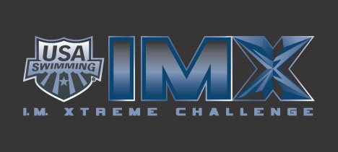

IM XTREME (IMX)
Ready to move forward? The next step is IM Xtreme (IMX). The IMX ranking includes a series of five

or six events at longer distances. Once you've completed the IMX program, you can find out where your IMX score ranks nationally, within your zone, within your LSC rank and on your club.

9 & Under; 10-year olds: 200 Free, 100 Back, 100 Breast, 100 Fly, 200 IM

11-year olds; 12-year olds: 400 Free (LC) or 500 Free (SC), 100 Back, 100 Breast, 100 Fly, 200 IM

13, 14, 15, 16, 17, & 18-year olds: 400 Free (LC) or 500 Free (SC), 200 Back, 200 Breast, 200 Fly, 200 IM, 400 IM

How do I score points?
Rankings in the program are based on power points a system developed by USA Swimming. See the Power Points page for more information and to use the Power Point Calculator.

How do I participate?
Participation in the IMR and IMX is easy. USA Swimming automatically scores and calculates results for all athlete members! Swimmers only need to sign up for a Deck Pass Account, then compete in each required event, at a sanctioned meet, at least once in a season.

Swimmers have the option of printing certificates that displays their scores for either IMR or IMX. They can also optionally print their national, zone, LSC and/or club rankings for IMX.

Coaches' IMX Listing
A coach can see a listing of his/her team’s IMR and IMX Scores through the coach’s Deck Pass page or the Club Portal.

VIRTUAL CLUB CHAMPIONSHIPS (VCC)
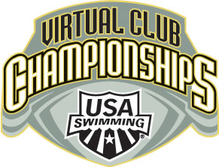
PROGRAM DETAILS
The purpose of the VCC program is to recognize and highlight clubs that are developing athletes and achieving success at multiple levels in the club swimming continuum emphasizing the team element in club swimming. This program serves as a key part of the Athlete Development & Performance component of the Club Recognition Program.
Period. The Virtual Club Championships will be tabulated annually for both the short course and long course seasons. Both Short Course Yard (SCY) and Long Course Meter (LCM) rankings will be tabulated using results achieved between September 1 and August 31. (Prior to the SCY 2008-2009 season the yards season was from 9/1 to 5/31 of the following year.)
Tabulation. All registered USA Swimming clubs will be scored automatically. The USA Swimming Star Times Data Base will be used in combination with the Hy-Tek Single-Year Age Group Power Point system. The program scores single age groups from 11-16 years old and has a combined 17-18 age group. After all eligible swims have been scored using the power point system, a team score for each registered USA Swimming club will be calculated. The tabulation will occur once every evening.
Team Event Limit. Each team will be limited to two entries per event by age group and gender. The program will automatically tabulate which two events in combination with other teammates produce the highest team score.
Individual Event Limit. Each swimmer will be limited to four events. A swimmer may contribute only four times per season even if they age up (i.e. may have two times selected as an 11-year old and two as a 12-year old, but not four as an 11-year old and four as a 12-year old). The program will automatically tabulate which four events in combination with other teammates produce the highest team score. For larger clubs, the computer will go through more than 1,000,000,000,000 (1 Trillion) calculations to determine the optimum score!
Eligibility. For a swimmer’s point total on a specific swim to count toward the overall team total, the athlete and/or their swim must meet the following eligibility criteria:
- Times must have been achieved while representing a registered USA Swimming club (no unattached times may be used).
- Age Groups and Events. The following event results will be tabulated for both men and women:
  - 11 & 12 year olds – 50 Fr, 100s of each stroke, 200 Free, 4/500 Free, 200 IM (8 events).
  - 13, 14, 15, 16, 17-18 year olds – All recognized Olympic events (13 events) plus the long distance event not swum at the Olympics (Men's 1000y/800m freestyle and the Women's 1650y/1500m).
- No relays will be scored.
The Virtual Club Championship rankings are updated nightly with any new times submitted by Local Swim Committee (LSC) times volunteers.
View Options. All SCY seasons prior to the 2008-2009 season are 9/1 to 5/31 of the following year and starting with the SCY 2008-2009 season the dates are 9/1 to 8/31 of the following year. The LCM seasons are all 9/1 to 8/31 of the following year.
A viewer has four options to look at their club ranking:
- If you select no option you will see all clubs sorted by national rank.
- Select Club will see only the selected club (it will show the national rank and then show VCC rank=1).
- Only looking at clubs in their LSC (will show the national rank first then the rank within the LSC).
- Only looking at clubs in their Zone (will show the national rank first then the rank within the Zone).
"View Detail" Option. A team may choose to look at the detail summary chart by clicking on the View Detail link on the far right-hand side of the ranking. At the beginning of the report, the viewer will see a chart that will quickly give coaches the ability to assess strengths and weaknesses of the team.
- Sprint freestyle for 11 & 12 year olds includes: 50 & 100 freestyles.
- Sprint freestyle for 13-17/18 year olds includes: 50, 100, 200 freestyles.
- Distance freestyle for 11 & 12 year olds includes: 200 & 400/500 freestyles.
- Distance freestyle for 13-17/18 year olds includes: 400/500 freestyle, the 800/1000 freestyle and the 1500/1650 freestyle.
- The 11 & 12 year olds in the IM column only have the 200 IM while the 13-17/18 year olds include the 200 and the 400 IM.
Following the chart is the detail breakdown of every swimmer that was used in the computation of the team's score. Below is a sample of the View Detail Summary report.
Sample Detail Report:
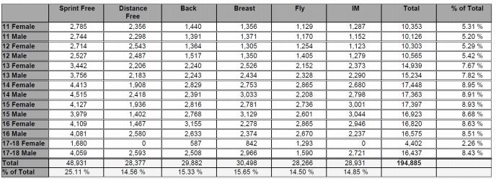

Club Recognition Program

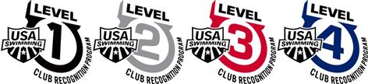

Have you ever wondered what "great" clubs do to be great? That question is at the heart of the Club Recognition Program (or CRP). This program offers our club members a working blueprint for developing strong, stable, financially sound and athletically productive organizations.
Designed by USA Swimming's National Club Development Committee (comprised primarily of coaches), this voluntary program presents four levels of achievement across four component areas deemed critical to long-term club success (Level IV is the highest level). The program encourages clubs to establish organizational goals and to benchmark their progress toward those goals.
The ultimate objective of the program is to strengthen the club system in USA Swimming by guiding clubs through a development process that ultimately positions the program and its coaches to better serve athletes.
The Club Development Committee looked at many different factors that helped create "great" clubs. The committee grouped all of the factors into four major component areas:
- Business & Organizational Success
- Parent & Volunteer Development
- Coach Development & Education
- Athlete Development & Performance
WHAT IS INVOLVED?
The program is entirely web based. Some markers require specific actions by the club. For example:
- Check lists. Example: the club conducts a business insurance review. Yes or No?
- Fill in the blank. Example: the club is asked to enter its mission statement.
- Upload documents. Example: the club is asked to upload a copy of its bylaws.
- Some are automatic based on queries to the USA Swimming Star Times database. Example: the system will determine whether 50% of the clubs swimmers have participated in at least 6 swim meets within the past 12 months.
Upon completion of a level, a club is able to print a certificate showing completion of that level. The club's achieved level is also automatically listed in the club search feature on the USA Swimming website.
HOW DO I GET STARTED?
Participation in the program requires an investment of time and attention by each club. As with anything that provides true benefit, we believe this investment is worthwhile and will pay significant dividends over time. We encourage the leaders in your club to look into the program and how it can benefit your organization.
A club enters its information through the administrative login section of its club portal. All Head Coaches were given a password to their Club Portal area. Note: This is a distinct password separate from your personal account password. You must have a USA Swimming account and login to the website in order to access the Club Administrator login screen.

Below is a list of benefits of USA Swimming memberships. It is important that our members understand the various ways that our national governing body, USA Swimming, brings value to their participation in this wonderful sport. From a global perspective, here are some of the primary functions performed by USA Swimming.

- Administrate the sport.
- Formulate the rules.
- Provide services and programs to all levels of membership.
- Conduct national championships.
- Promote and market the sport.
- Disseminate safety and sports medicine information.
- Provide educational programs for coaches and parents.
- Select athletes to represent the United States in international competition.
Following is a listing of the primary benefits of membership for athletes, clubs, and coaches. In several instances, a program or service may directly target one member entity while providing indirect benefit to another.

Membership Benefits for Athletes
- Eligibility to participate in sanctioned competition throughout 59 Local Swim Committees (LSCs) that provide several levels of development for swimmers of all ages and abilities.
- Receipt of Splash Magazine, a bi-monthly publication for athlete members.
- An extensive website providing information that is structured by and serves all membership categories. A few specific items that can easily be utilized swimmers and their parents include the Nutrition Tracker and nutrition information, the Times Database, and special “Swimmers” and “Parents” sections.
- Scholastic All-American program honoring high school age athletes who excel in the classroom and in the pool.
- IM Xtreme Challenge – a motivational program whereby swimmers are scored and ranked nationally on their performance in a combination of five or six events. The purpose of the program is to promote versatility in age group swimming while advocating greater participation and development across a range of events that are integral to long-term success in swimming.
- Drug and doping control information for swimmers and parents

